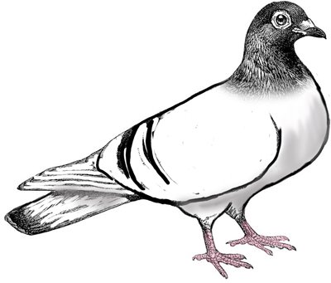
Name: ______________________________________________
Class: ____________
Wringer Poster Assignment

Set up: Imagine that you live in Waymer (the same town as Palmer LaRue) and Family Fest is coming up. You’ve either been dreading Pigeon Day OR looking forward to it all year.

Goal: Convince the people of Waymer to stop Pigeon Day! OR Promote Pigeon Day to the town of Waymer!

Task: Create a poster showing how you feel about Pigeon Day.

Your poster must…
- clearly show your support for Pigeon Day or how you disagree with Pigeon Day. (Do you think the pigeons should be shot or do you want to save the pigeons?)
- include at least two pictures. (Feel free to: print from the computer, cut out of a magazine, draw by hand, use a real photograph…)
- include at least three facts from any of the articles we read. (You choose what information fits for your poster!)
- have at least one detail from the book. (Check out the news article that appears in the beginning for some good ideas, if you want.)
- be colorful and creative!

POSTER IS DUE ON: __________________________________________________

For every day your poster is late, 5 points will be deducted.
Requirements | Points Possible | Student Evaluation | Teacher Evaluation
Poster clearly shows agreement or disagreement with Pigeon Day | 10
Poster includes two relevant images | 10
Three facts from news articles are on the poster | 15
Poster includes one detail from Wringer | 5
Poster is NEAT, colorful, and creative | 10
Total Points | 50
You must submit THIS sheet with your poster.

